

Sponsorship Proposal

Fashion Shows have always been Glamorous Events which boost Visibility and Promotion of Brands associated.

Business Sponsorship is a major source of funding for many events as more and more companies have discovered this to be a powerful marketing tool.
Build and strengthening your company brand through effective visibility is one of the key essentials in business strategy.

What I’m offering is a great and glamorous way to promote your Logo in a way that everyone knows it’s a great Brand and a great company to support this fashion show for a great cause.

This event is a non-profit event I desperately need your help of sponsorship to do this event for these charities and to promote your Logo and Brad, I have put in all my time into this event for the past 2 months till 17th may and will be putting more of my time for charity in the future.

Format of the Fashion Show

Champagne On arrival, reception will be held from 20:00 to 21:00.

There are 21 tables all around the Runway; the Runway is designed into an (L) shape,
42meters of Red Carpet and chrome posts on each side.
Runway Presentation begins at 21:00 till 23:00 followed by Brazilian Dancers for the closing ceremony and the after party will start till 02:00.
Free Parking at the back entrance of Gilgamesh.

Thank you so much for your time in reading this letter and hope you will be able to sponsor this event and let it happen.

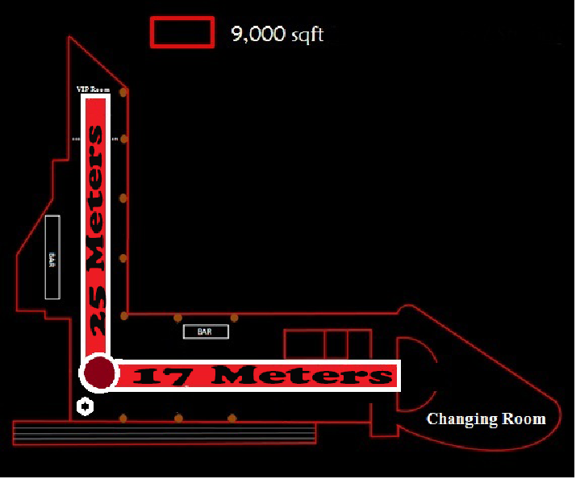
For more information about this sponsorship proposal please contact me on 07866333334 or you can E-Mail me at; Rabihmalaki@dress2impressevents.co.uk.
Gilgamesh Runway Plan

I will look forward to hearing from you.

Thank you very much

Means of Sponsorship

Gold Sponsor (£2000)
- Table up to 8 people complimentary entry with Sponsor’s Logo/Name is displayed on the Table, with 2 bottles of spirits and Mixers. (Value £600)
- Table supported by sponsor (i.e., each person at the table receives a promotional item
from the Sponsor (Optional)
- Logo on Event Invitation
- Name/Logo on all advertisements (Flyers, Newspapers, Social media Etc.
- Sponsor banner or logo displayed on podium
- Log Recognition on the Fashion Show Website
- Thanking and Mentioning your company on the night
- Opportunity to provide product / Coupon in gift bag ( Optional )

Silver Sponsor (£1500)

- 6 Complimentary Tickets to the Fashion Show ( £180 )
- Logo on the Event Invitation
- Logo recognition on the fashion Show Website
- Name/Logo on all advertisements (Flyers, Newspapers, Social media Etc.
- Sponsor banner or logo displayed on podium
- Thanking and Mentioning your Company on the night
- Opportunity to provide product / Coupon in gift bag ( Optional )

Bronze Sponsor (£1000)

- 4 Complimentary Tickets to the Fashion Show ( £120 )
- Logo on the Event Invitation
- Logo recognition on the fashion Show Website
- Name/Logo on all advertisements (Flyers, Newspapers, Social media Etc.
- Sponsor banner or logo displayed on podium
- Thanking and Mentioning your Company on the night

Thank You for your commitment as a sponsor for this Spring/Summer Charity Fashion Show 2013, and Great Ormond Street Children’s Hospital and Cancer Research.

Business Name (as it should appear in Marketing Materials):

……………………………………………………………………………….

Contact Address ……………………………………………………………..

E-Mail Address ……………………………………………………………...

Mailing Address …………………………………………………………….

City ……….................Town ………………………Post Code………..........

Phone ………………………………… Fax ………………………………..

In support of Dress2impress events Spring/Summer 2013 Charity Fashion Show for Great Ormond Street Children hospital and Cancer Research,
My Company hereby pledge(s):

Type of Sponsorship

Gold Sponsor (£2000)

Silver Sponsor (£1500)

Bronze Sponsor (£1000)

………………Check Enclosed (Please make checks payable to: Dress2Impress Events LTD

………………Credit Card (Please complete the card details below).

Please Charge £…………….....To my:

Visa MasterCard American Express Other ……………........

Credit Card Number ……………………………. Expiry Date……/………/……………..

Sort Code ………../…………. /…………..

Billing Address………………………............................. Billing Post Code ………………

Cardholder’s Signature ……………………………………………..

Please Return to; Rabih Malaki, 79D Leverton Street, London NW5 2NX

