WELCOME TO

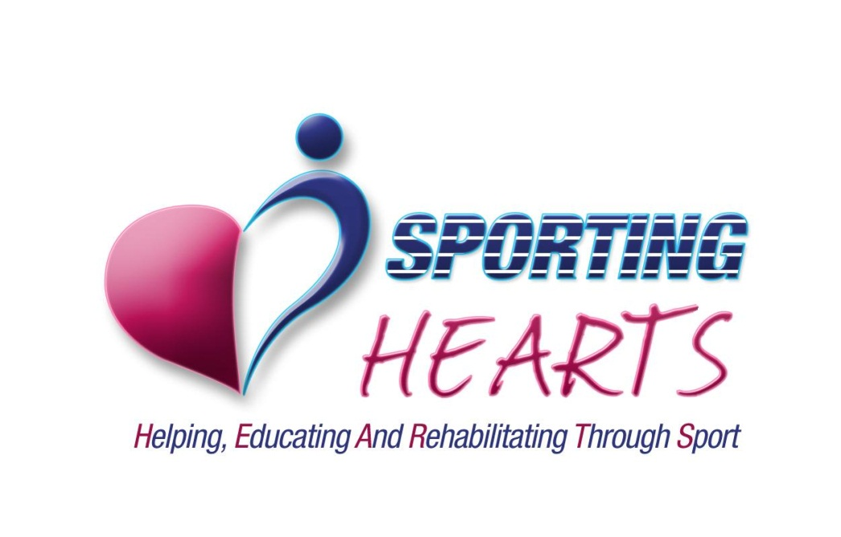



Honourable President: Mr. Paul Hart

ABOUT US

SPORTING HEARTS is a social enterprise – represented by business and sporting specialists – with the vision to improve the quality of people’s lives by helping, educating and rehabilitating through sport. We are determined and committed to achieve national recognition in this respect.

We will achieve this, by using the following six-stage progressive process:

- Carefully selecting people who have the necessary motivation and commitment, ensuring they match – and embrace – Our Heart
- Organising our Efficient Finance, to ensure maximum impact of our efforts
- Uniting the above two to create – and support – innovative and life-improving Sustainable Projects
- Identifying Business Development opportunities, that offer qualitative and quantitative benefits
- Selecting appropriate Media & Marketing, which communicate the impact of our work efficiently; recognising the invaluable support of all our various teams and supporters
- Subjecting everything to a continuous improvement cycle, based upon Evaluation & Review, in order to ensure on-going enhancement.

Philosophy & People

SPORTING HEARTS is a not-for-profit, Private Company, limited by Guarantee, without share capital, registered in England and Wales. Our first year will very much be one of laying firm foundations – based upon developing mutually beneficial key partnerships – with suitably motivated and committed people. We recognise an organisation’s strongest assets are its people and we firmly believe we have a very special group of individuals who care passionately about improving the quality of people’s lives within the communities in which we operate. The Board is deliberately constructed around a minimalistic approach – to enhance the decision-making process – containing the 7 key roles of:

- Chairman
- Managing Director
- Company Secretary
- Finance Director
- Project Development Director
- Marketing Director
- Fund-raising Director

Our infrastructure has carefully been constructed to accommodate and promote sustainable growth, contained within the following sets of four teams:

BOARD OF DIRECTORS

PRESIDENT & AMBASSADORS

PROJECT MANAGERS

ASSOCIATES

What we do

We realise that everybody is different and has individual needs, especially those from disadvantaged backgrounds. To this end, we take the time to find out what they would like to do in their spare time, in order to cater to their needs in the best possible manner.

Our work is fully inclusive and we encourage everyone to be in charge of their own destiny. In order to do so, we have created many links with educational and vocational supporters within our communities, so we can signpost our individuals into a variety of pathways to success.

Our Business Model

Our Business Model is based on continuous evaluation of – and information from – all strategic divisions in order to ensure healthy growth and development. The illustration below visualises this on-going process:

This model is then broken down further, into six more detailed outlines, as depicted on the following pages.

Our Heart is based upon:

- Spreading our Inspirational Vision, so everyone knows exactly and what we do and how we do it
- Encouraging the required Motivation & Commitment amongst us and all our Associates
- Introducing and developing new ideas, based upon Creativity & Innovation
- Combining all of the above, to ensure Efficient Finance
(Please see next page)

Our Efficient Finance is based upon:

- Maximising Income, through grants, sponsorship, donations and events
- Minimising Expenditure on all core costs
- Ensuring our Cash-flow is always healthy and protected
- Merging the factors above in order to fund Sustainable Projects

Our Sustainable Projects are based upon:

- Creating Life-improving initiatives
- Adopting the ‘Teach Them to Fish’ strategy
- Realising an Accurate ROI – both qualitatively and quantitatively – to ensure future initiatives
- Integrating all of the above by actively seeking for and embracing Business Development opportunities

Our Business Development is based upon:

- Practising efficient Administration, especially regarding our policies & procedures
- Always providing an Realistic ROI to our various supporters
- Growing our Teams & New Partnerships – encompassing the Board, President & Ambassadors, Support Groups, Project Managers and Associates
- Incorporating all of the above to develop and maintain appropriate Media & Marketing strategies

Our Media & Marketing is based upon:

- Selling The Vision to secure support from appropriate quality people and organisations
- Increasing Awareness, via the appropriate media and Ambassadors
- Promoting our work by Maximising PR Opportunities
- Fusing all of the above before subjecting everything to Evaluation & Review regarding effectiveness and appropriateness

Our Evaluation & Review is based upon:

- Analysing whether our work has a positive Life-changing Impact
- Always looking for Improvement Strategies, based upon Covey’s ‘Seven Habits of Highly Effective People’
- Using Qualitative & Quantitative Feedback for assessment
- Taking everything into account, evaluating whether we are achieving our Inspirational Vision; if not, reviewing and redefining any necessary action

Our Future

Although SPORTING HEARTS is a newly-formed organisation, it is immensely proud of what has already been achieved; we have set up local projects, based upon getting children involved in Thai Boxing, running, football and dancing, to name only a few.

If you believe you have the necessary heart, motivation & commitment to contribute and help us achieve our Inspirational Vision, SPORTING HEARTS would love to hear from you, even if you’re not quite sure what you will do yet.

THANK YOU VERY MUCH FOR YOUR ATTENTION!

