Arawak Carnival Club
The Notting Hill Carnival 2012
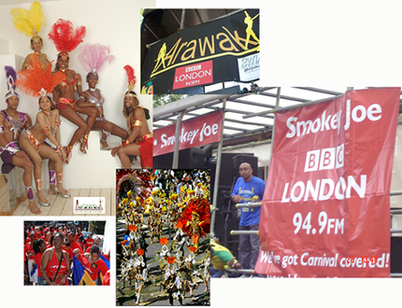

Arawak presents a unique opportunity to participate and support Europe’s largest event in the festival calendar. (See http://www.thenottinghillcarnival.com)
With over 2.5 million people descending on Notting Hill over the August Bank holiday, Arawak Carnival Band continues to grow as a premier costume brand, showing cultural themes and designs direct from Trinidad & Tobago for spectators, organisers and other masquerade participants.

Broadcast Media
Arawak Carnival Club has a history of high visibility media coverage during the Carnival, due in large part to a longstanding support relationship with the BBC London 94.9fm (TV, Radio and digital). The BBC News inserts also footages featuring Arawak costumes to TV coverage during the carnival. This relationship has established Arawak as a broadcast media ‘friendly’ brand. Arawak are adept at recognising and maintaining excellent communications and broadcast opportunities during the carnival season.

Arawak marketing and sponsorship profiles
The spectacular show and activities surrounding the carnival are hosted by Arawak without government or Notting Hill Carnival Trust (Ltd) support. Arawak’s show attracts Masqueraders from all communities nationally. The road is their stage and as such presents an unprecedented platform for advertisers and sponsors to achieve marketing goals, with high visual presence, sampling opportunities and creates emotional resonance with spectators and Masqueraders alike.

Arawak will give the opportunities to businesses to promote their
products and services to over half a million people in London (local
and visitors).

Arawak sponsorship Packages:
All sponsorship plans are customised to maximise effectiveness. The sponsorship opportunities are varied. Briefly they are as follows:

Gold Sponsor: £25,000
A Gold sponsor will be the headline sponsor of Arawak Carnival Club (The
commercial rate card of the media coverage is valued at GBP £70,000)
As a gold sponsor you will benefit of the following:
- Company Name & logo On 500 T-Shirts.
- Company Name & logo to appear prominently in a signage on the front Truck.
- Your company name incorporated into all press releases in the run up to the Carnival’s final day. The coverage of Arawak has been featured in the past years by the national press (the Independent, The Voice Newspaper, the Evening Standard and Caribbean Times); this year Arawak seeks more press coverage within targeted Journals.
- Company logo in all marketing leaflets. 20,000+ flyers will be distributed through Arawak members network, the UK CMA (Caribbean Music Association), at the Arawak Launch event (and throughout registration period July - August) and at other events such as Panorama (National Steel band Competition) and other ad-hoc Caribbean music events. There will be also an additional publicity aimed at grass roots supporters of Carnival’s cultural activities through community radio stations and local Caribbean music events.

Silver Sponsor: £12,500
As a silver sponsor you will benefit of the following:
- Company Name & logo to appear prominently in a signage in the second Truck.
- Company logo in all marketing leaflets. 20,000+ flyers will be distributed through Arawak’s member network, the UK CMA (Caribbean Music Association), at the Arawak Launch event (and throughout registration period July - August).

Bronze Sponsor: £5,000
As a bronze sponsor you will benefit of the following:
- Company Name & logo to appear prominently in a signage in the team’s bus.
- Company logo in all marketing leaflets.

