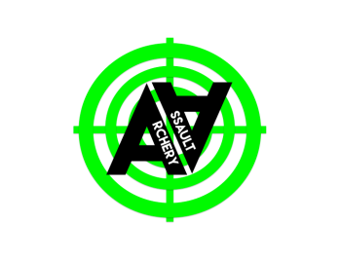
Sponsorship Outline
Company Name: ARCHERY ASSAULT LTD
Registration Number: 10533761
Registered Address: 6 Keppel Place, Stoke, Plymouth PL2 1AX
Incorporation Date: 20th December 2016
Contact: Stephen Whitfield, Director
Telephone: 07739517327
Email: support@archeryassaultplymouth.co.uk

Archery Assault is a cardio-intensive, affordable, safe, competitive, teams-driven activity, intended to engage people from the ages of 9 and up, on an open terrain, where success is based on communication and quick-thinking.
We see our marketplace as consisting of three distinct sectors, though there may be cross-overs;
- Corporate i.e. businesses who are seeking novel ways to engage with their staff in team-building or bonding exercises. Initial contacts into this sector have been very positive.
- Sports clubs and educational establishments who wish to foster cooperative endeavours in building team spirit, etc.
- individuals who either currently or wish to engage in 'combat' sports, who are fit enough so to do, are at least 9 years old and are seeking something different to paintball or airsoft, etc.
Our offering is different to other activities that might, superficially, appear similar
- What once was exclusive to archery clubs and those willing to spend large sums of money, has been made affordable and engaging, it's so much fun that players will not realise just how much exercise they are doing.
- There is no need for the player to invest in special equipment as all necessary items are provided by Archery Assault, although we recommend the purchase and use of groin protectors.
- Ammunition, once used in other sports is spent. In our game, it becomes reusable so players do not incur the expense of buying new ammunition.

We expect customers will buy from us because:
- There are no local direct competitors offering the same service.
- We offer a different style of game that will attract those who currently engage in paintball or airsoft, without necessarily taking custom away.
- We could be considered as offering a complementary service but Archery Assault is more affordable – at half the price of our nearest direct competitor, indoor-outdoor flexible and child-safe. We're safer than air-soft and paintball.

What is on offer for sponsorship; (Packages: Silver, Gold and Platinum)
Platinum(£2000): Your logo on our website, our clothing, our banners, literature and all our social media (facebook, twitter, linkedin, tumblr, yahoo, instagram and youtube).
Gold(£800): Your logo on our website, our clothing and our literature.
Silver(£500): Your logo on our website and our clothing.
Bronze(£250): Your logo on our website.
(all logos to be provided by sponsor; digitally for all but clothing, patches with logo on will be no more than 4inches x 6inches at their largest dimensions)

The benefits;
Anyone who sponsors our company, will, in turn, improve their own image and have their awareness increased in potentially previously untapped market sectors in Plymouth and the surrounding areas, until such time as we expand beyond.
They will have the opportunity to leverage their association with us to turn the relationship into big news, thus boosting their own fame and enhancing public perceptions of themselves.

