Andrea Borrelli and Chantal Green (England WDSF No. 1 couple)
Andrea Borrelli and Chantal Green are a very promising and committed English Latin dance sport couple who are currently the number 1 ranked English WDSF (World Dance Sport Federation) Amateur Latin dance partnership. They would be honoured to promote and represent your company during international competitions.
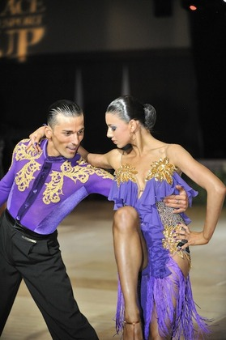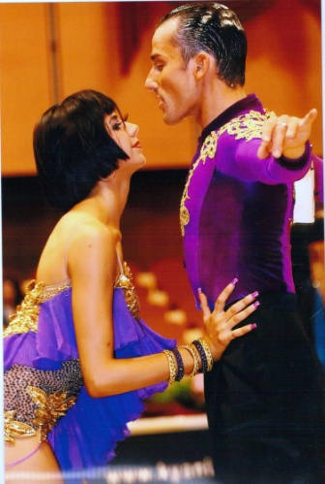
Andrea and Chantal compete in Amateur Latin at World Dance Sport Federation (WDSF) competitions internationally representing England. They train at the world famous Team Diablo Institute in Italy coached by Gabriele Goffredo and Anna Matus. Although a fairly new partnership of eighteen months, they have already been selected to represent England five times by Dancesport England.
Selected by Dancesport England to represent England at the European Amateur Latin Championships in Barcelona – April 2012
Selected by Dancesport England to represent England at the European Latin Cup in Hungary – June 2012
Selected by Dancesport England to represent England at the World Amateur Latin Championships in Vienna – November 2012
Selected by Dancesport England to represent England at the World Latin Cup in Vienna – September 2013
Selected by Dancesport England to represent England at the World Amateur Latin Championships in Berlin – November 2013
As Andrea and Chantal are currently the top English WDSF Amateur Latin couple, this would be an opportunity for you to have your brand represented at all the top WDSF Amateur Latin competitions requiring national selection; your brand will be represented on the floor by an English Latin couple around the world.
There are opportunities to have your logo displayed on our dancewear, tracksuits, luggage as well as on their website, Facebook and Twitter *. They would also be happy to participate in any advertising photography you require and support any promotional events for your company with appearances or demonstrations**.
Andrea and Chantal believe they have the talent, work ethic and commitment to achieve in their dancing and want to be able to focus on this fully; realistically to do this they need to obtain financial support and sponsorship. They plan to compete internationally every month in addition to any “by selection only” events to ensure that they steadily climb the world rankings. To achieve this they have a very structured six day training programme at Team Diablo organised by their coach Gabriele Goffredo who along with his partner Anna Matus are the world number 2 ranked WDSF Amateur Latin couple. As they are a fairly new partnership, an appendix is included listing some of their previous achievements with previous partners to demonstrate their commitment and standard of dancing.
If you would like to speak with Chantal and Andrea or meet for further discussions please email chantalgreen@msn.com. Any support that your company can offer will be greatly appreciated. Thank you for reading this letter and giving your consideration.
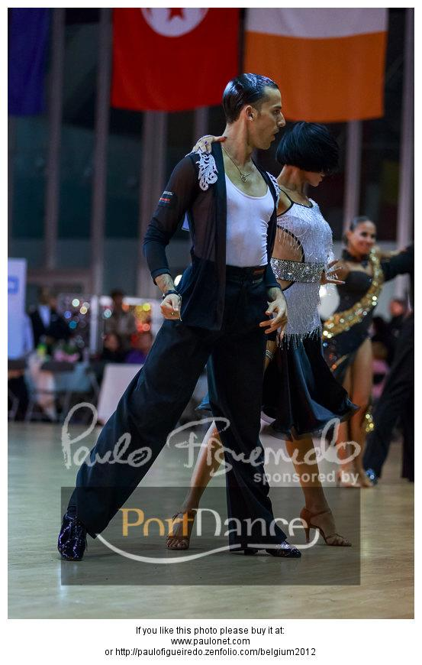
* www.chantalandandrea.co.uk
www.facebook.com/chantalandandrea
** subject to their competition schedule

Please visit website for more detail and photographs
www.chantalandandrea.co.uk

Appendix of Information on Andrea Borrelli and Chantal Green

Name: Andrea Borrelli DOB:11/11/1987
Italian Mobile / e-mail: +393488719664/andreadance87@hotmail.it
Website: www.chantalandandrea.co.uk

Previous individual dance achievements;

• Finalist in Italian Amateur Latin Championships 2008
• Semi-finalist in German Open Amateur Latin 2011
• Winner of San Marino Dancesport Grand Prix Amateur Latin 2011
• Semi-finalist in Bulgaria WDSF Amateur Latin 2011
• Semi-finalist in Romania WDSF Amateur Latin 2011
5 year Diploma in Dancesport completed at Team Diablo Institute

Name:Chantal Green DOB:29/04/1993
Italian Mobile / e-mail: +393409538596/chantalgreen@msn.com
EnglishMobile 07792278418
Website: www.chantalandandrea.co.uk

Previous individual dance achievements;

• Selected to represent Wales at WDSF European Youth Latin Championships in Barcelona in 2011
• Selected to represent Wales at WDSF European Youth Ballroom Championships in Austria in 2011
• Selected to represent Wales at WDSF World Youth Ten Dance Championships in Moldova in 2011
• No.1 Welsh Youth Ballroom and Latin couple in 2011. (WADSA)
• Selected to represent England at WDSF European Youth Ballroom Championships in Poland in 2010
- No.3 England Youth Ballroom and Latin couple in 2010. (EADA)
2 year Diploma in Dancesport completed at Team Diablo Institute

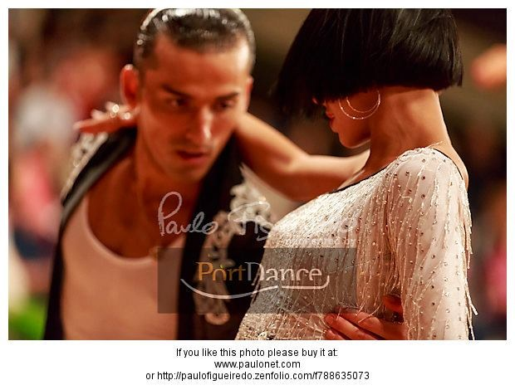
Recent Competition Results

Open Latin, Ancona, Italy, October 2013 – 4th place

Rising Stars Latin, Steenwijk, Holland, October 2013 – 6th place

World Open Latin, Steenwijk, Holland, October 2013 – 16th place

World Open Latin, Gothenburg, Sweden, September 2013 – 15th place

Grand Slam Latin, Stuttgart, Germany, August 2013

World Open Latin, Chisnau, Moldova, April 2013 – 29th place

Open Latin, Monticello, Italy, April 2013 – 7th place

Open Latin, Molinella, Italy, April 2013 – 2nd place

World Open Latin, Pieve de Cento, Italy, March 2013 – 28th place

Rising Stars Latin, Pieve de Cento, Italy, March 2013 – 17th place

World Open Latin, Brno, Czech, March 2013 – 33rd place

Rising Stars Latin, Brno, Czech , Italy, March 2013 – 12th place

World Open Latin, Maribor, Slovenia, December 2012 –21st place

World Open Latin, Paris, France, November 2012 –20th place

World Open Latin, Oradea, Romania, November 2012 –21st place

