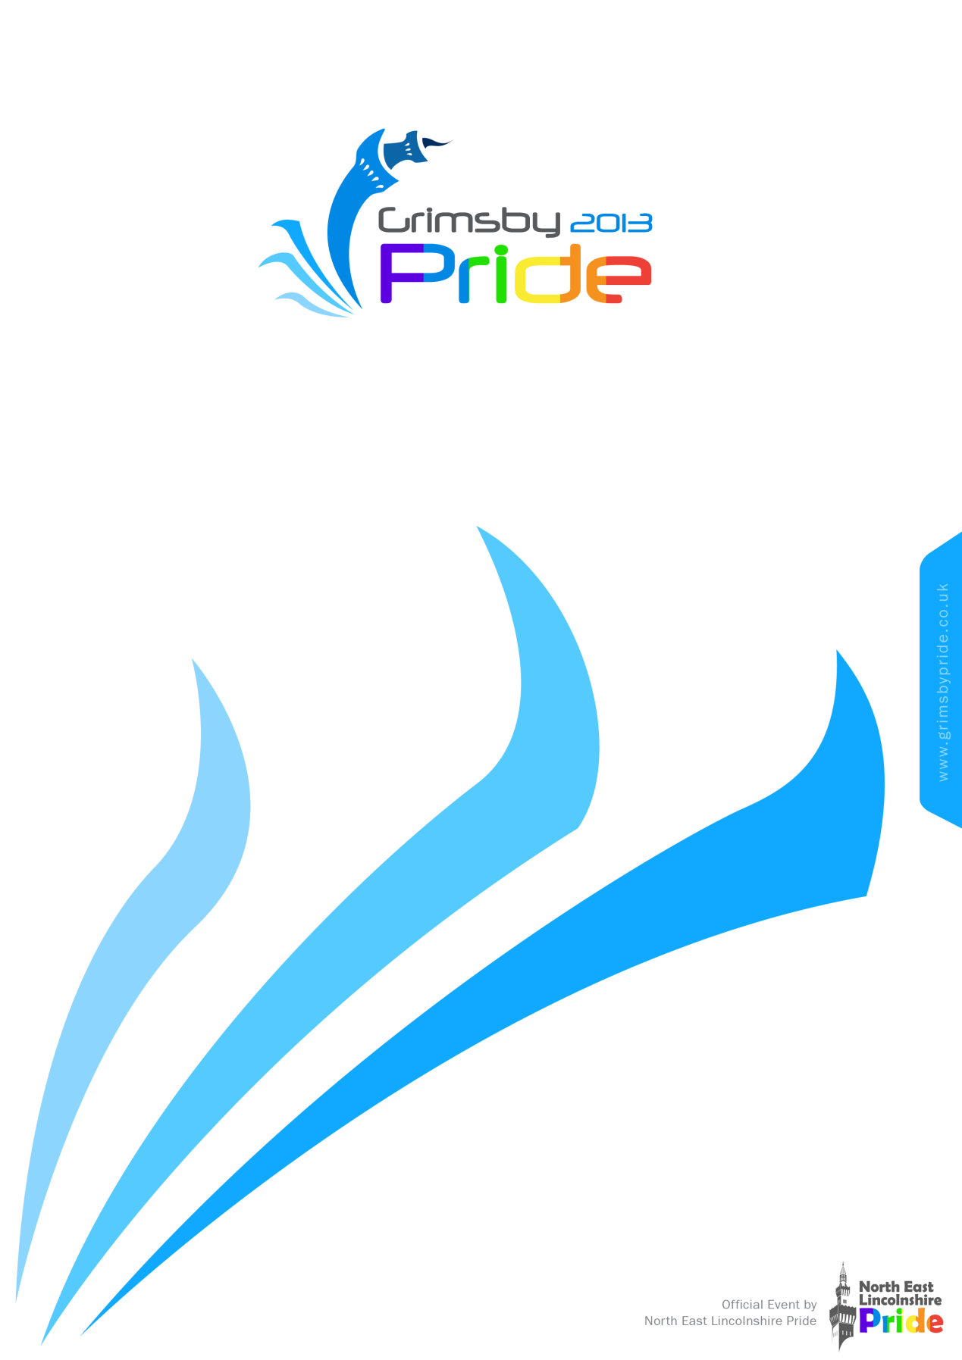
Sponsorship Pack
Registered Charity No: 1146977
Contents
Introduction 3
Get Involved 3
Sponsorships 3
Why sponsor Grimsby Pride? 3
Key facts and figures: 3
Charitable Aims and Objectives: 3
To deliver an annual one day event that aims: 3
The objectives and activities of the group shall be: 3
Packages: 3
Bronze Package - £100, includes: 3
Silver Package - £250, includes: 3
Gold Package - £500, includes: 3
Cleethorpes Carnival -2013 3
Area Packages: 3
Stage Act Sponsorship – From £200: 3
Committee T-shirt Sponsorship - £250: 3
After Party Wristband Sponsorship - £250: 3
Main Event Wristband Sponsorship - £500: 3
VIP Area - £1000: 3
Main Gate - £1500: 3
Main Stage - £2500: 3
Contact Information 3

Introduction
The North East Lincolnshire Pride (Trading as Grimsby Pride) committee are once again presenting our Pride fun day, which will take place on Saturday 31st August 2013, at Meridian Park, Cleethorpes. The event will take place between 11am and 7pm. The aim of the event is to raise awareness and social integration of the Lesbian, Gay, Bisexual and Transgender (LGBT) community and other strains of the diverse communities with the North East Lincolnshire area. As I am sure you are aware, it can be very difficult for all people that are unsure about their feelings with regards to their sexuality. We can offer support and encouragement through professional bodies and organisations that will be present on the day to help people through what can be a very troubling time. It also offers them the opportunity to enjoy a fabulous day with like-minded people.
Last year’s event was hugely successful with thousands of people attending throughout the day, where they enjoyed a fantastic array of headline acts, local acts and a wealth of information, health awareness and retail stalls. We are looking to increase the attendance figures for this year and are planning a fantastic line up of entertainment and attraction to ensure a great success.
We are a non-profit organisation with every member of the committee being volunteers. Unfortunately due to funding cutbacks within the local authority we are seeking additional funding, sponsorship and donations. With this in mind, on the following page is a compilation of packages available for your consideration. We hope that you can support us in some way no matter how great or small.
2012 saw the management committee apply to the Charities Commission to become a registered charity. This process is currently on-going.
In addition, we are in a growing, developing and exciting partnership with Grimsby Institute developing a support group for the LGBT Youth of North East Lincolnshire. Due to unforeseen circumstances the start of this project was delayed and thus will be unveiled throughout 2013.

Get Involved

Sponsorships
Sponsorship partnerships are essential to the success of any Pride Event, both locally and on a national scale, and such long-term partnerships clearly bringing mutual benefits to both parties.
Grimsby Pride believes that flexibility and involvement are key to a successful partnership; therefore packages can be tailor-made to meet your requirements.
To ensure that your sponsorship objectives are met, be they diversity awareness, recruitment for Lesbian, Gay, Bisexual and Transgendered employees, or to help market a new product into this key market, identified personnel will be provided.
We are not only able to target specific demographics within the LGBT community but also to a wider demographic as individuals represented by the seven strands of diversity attend the event.

Why sponsor Grimsby Pride?
As a sponsor of Grimsby Pride 2013 you will benefit from:
- Regional, and national enhanced brand awareness and profile
- Opportunities for highly-targeted marketing, public relations and brand building.
- Exclusive sampling and promotional opportunities
- An opportunity on a diverse platform to show your support for LGBT issues and demonstrate your commitment as an all-inclusive employer.

Key facts and figures:
- Teen Suicide
- In 2009, 2010, 2011 and 2012 Grimsby Pride attracted growing numbers of people from all walks of life to the diverse events including the festival which once was thought as something that would never happen within the North East Lincolnshire region.
- Audience demographics for Grimsby Pride were 42% female and 57% male. 88% of all visitors were in the 16-44 age group.
- Grimsby Pride events are continually growing in numbers and also attracts visitors from all over the region, UK and Europe, the estimated spend by gay visitors to the UK is over £3 billion. This is obviously more beneficial to larger cities.
- Visually supporting your LGBT workforce who may not realise your inclusive practice and policies as an employer.

Charitable Aims and Objectives:

To deliver an annual one day event that aims:

- To promote LGBT equality with the wider community
- To promote the community in issues surrounding sexuality
- To promote LGBT issues
- To provide a ‘family fun’ event including music, entertainment and stalls. With a market place where other organisations can promote their services to the community
- To secure a venue for a monthly night which gives the LGBT community a safe and secure place to go
- To set up a group to provide support for members of the LGBT community between the ages of 16 – 21

The objectives and activities of the group shall be:

- Secure and safeguard appropriate funding to deliver the aims of the group
- Co-ordinate and encourage community engagement through fundraising and promotion events throughout the year
- Manage, in its entirety, the planning, organising and management of the event
- Document appropriate analysis and post evaluation of the event

Packages:

Bronze Package - £100, includes:
- Logo coverage on our main event poster

Silver Package - £250, includes:
- Logo coverage on our main event poster
- Logo in our event guide
- Banner advert in event guide (as well as logo)
- Logo added to sponsors page on website

Gold Package - £500, includes:
- Logo coverage on our main event poster
- Logo in our event guide
- Banner advert in event guide (as well as logo)
- Logo added to sponsors page on website
- Half page advert in event guide
- Free stall at the event
- Your company/organisation logo on advertising for all Grimsby Pride events for 2013
- 2 Tickets for access to each event hosted by Grimsby Pride in 2013
- Mention of your group/origination on our social networking sites and all related media
- A link to your website from our website

Cleethorpes Carnival -2013

Grimsby Pride have participated in the Cleethorpes Carnival for the past 3 years and it is an ideal opportunity to advertise your company to a wide and varied audience. Last year 30,000 people attended the event, both local and tourists from out of town. The attendees make up a wide demographic and there is plenty of opportunity to target your marketing messages to a large number of prospects.
Each sponsor will have a spot to advertise their brand upon the float and will be featured on promotional literature. It is a chance for your company to promote its commitment to equality and progressive thinking, as well as its relationship with the local community with a positive and inclusive attitude.
This year’s carnival will be sponsored by Young’s Seafood Limited; they will be helping to fund and organise the event which will be held on the 20th July. The carnival has also been rebranded with a Brazilian style designed by a local design firm, which aims to add vibrant new life to the 36 year old event.

Area Packages:

Stage Act Sponsorship – From £200:
This package offers you the chance to sponsor an act that will appear on the main stage, act sponsorship starts from £200 depending on the profile of the act you wish to sponsor. When taking up this package your company/organisation will receive the bronze package (detailed above) as well as your company/organisation name in all our adverting, event guides and related media when we mention the act you sponsor E.G. “Bears Aloud sponsored by John & Co”

Committee T-shirt Sponsorship - £250:

The logo of your company/organisation will be placed on the back of all committee t-shirts. Every member of the committee has responsibilities in every part of the site on the day of the main event, so it’s a great way to advertise your company/organisation also includes bronze package

After Party Wristband Sponsorship - £250:

Every patron who attends Grimsby Pride 2013 after party will receive a wristband on entry. Your logo will be placed on every wristband, includes bronze package

Main Event Wristband Sponsorship - £500:

Every patron is given a wristband which gives them entry to Grimsby Pride 2013. Your logo will be placed on every wristband issued, includes silver package

VIP Area - £1000:

This package will include full and exclusive coverage and renaming of the arena itself plus all the benefits of the silver sponsorship package. Funds will go towards equipment hire plus ensuring we are able to deliver a high quality experience. This again will raise the profile of the event and make the VIP area a highlight of the day. Plus a feature advert in event guide

Main Gate - £1500:

This package will include full and exclusive coverage of the main gate itself plus all the benefits of the gold package. This gate is the only entrance for the general public to access the site so is an excellent point to advertise your company/organisation. As well as coverage you will have the opportunity to provide us with any promotional material that you may want to have handed out on the day of the event. Plus a feature advert in event guide

Main Stage - £2500:

This package includes full and exclusive coverage on main stage, the benefits of the gold sponsorship package and renaming of stage after your company or organisation. This will mean that in any publication or publicity when the main stage is mentioned it will be referred to as the ‘John &Co stage’ for example. A banner with your logo will be the backdrop of the stage, so all photography taken of the stage will feature your logo. This will go towards paying for the hire of essential equipment and to secure quality acts, which will raise the profile of the event and the companies involved. Includes gold package, a feature advert in event guide and your company/organisation will sponsor the headline act on the main stage

Contact Information

www.grimsbypride.co.uk
info@grimsbypride.co.uk

Chairman: Wayne Reece-Gorman
Mobile Tel: 07824875361
Email Address: wayne@grimsbypride.co.uk

