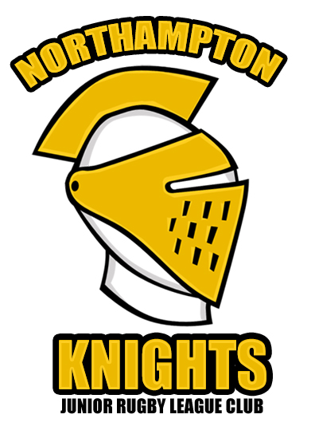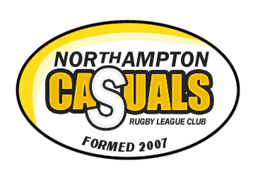

www.northamptonrl.co.uk

SPONSORSHIP OPPORTUNITIES WITH
NORTHAMPTONSHIRE’S RUGBY LEAGUE CLUB 2008

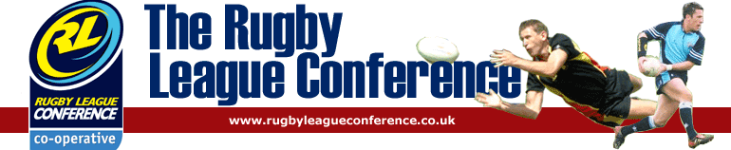

NORTHAMPTON RUGBY LEAGUE CLUB

We are a relatively new club entering a high profile league. We are offering a range of packages for your company to develop its corporate awareness amongst the club, its supporters and the wider Rugby League community. To cover our costs and to enable the club to fulfill all of its ambitions this season the club requires sponsorship to help with the running costs. These include match and training kit, transport to away matches, providing food to visiting teams and funds to help the development of the sport in and around Northamptonshire.
Whether your involvement comes through a love of Rugby League, a desire to promote your business through the fastest growing sport in the UK or simply a recognition of the benefits of association with voluntary organisations with a national profile, Northampton Rugby League Club has much to offer the potential sponsor.
Northampton already has links to Rugby League – in the early 1990’s a team played at Sixfields and competed in a National League but this venture only lasted two years. The University has had a highly successful Rugby League side, since 2001, competing in the National South competition against the likes of Loughborough University, Trent Poly and St Mary’s College Twickenham. With a unique position in the Northamptonshire sporting calendar, Northampton Rugby League Club offers value for money sponsorship opportunities.
Northampton Rugby League Club will gladly tailor a sponsorship/advertising programme to enable you to maximise your benefit from the country’s fastest-growing summer sport.
We offer a wide range of sponsorship opportunities, including Headline Sponsorship, Jersey Sponsorship, Player Sponsorships and Ground Advertising Boards.

UNIQUE SELLING POINTS OF THE CLUB INCLUDE:
- The season is structured with fixtures against other clubs in the League with an opportunity to go further with National playoffs. The matches will be reported in the local and national press along with the Rugby League media. Sky text carries the results of the games.

- The only dual-code Rugby club in Northamptonshire, offering the best training and good facilities for both codes of Rugby.

- The only Rugby League Club in Northamptonshire with both a Junior and Senior section.

- Sponsoring the match kit (front of shirt and shorts), seen by club opponents and their supporters. We have a clothing range which will feature our sponsor and will be worn as casual wear and seen by many.

- Sponsoring the club will be an opportunity for your company to advertise your company in the match day programmes, and to have a link on the club website with a subscribed newsletter that will be distributed amongst friends, family and supporters of the club.

- The only Northamptonshire based qualified referee who has officiated in junior matches at the 2007 Challenge Cup Final at the newly opened Wembley Stadium and is one of the junior coaches and founder members of the club.

- The club plays in a competition that stretches the length and breadth of the country.

WHY SPONSOR NORTHAMPTON RUGBY LEAGUE CLUB?
- Raise the brand / corporate awareness of your organisation within Northamptonshire. We will positively promote the company you represent.

- Joining forces with Northampton Rugby League will show that your company cares about the community in which it operates.

- Sponsorship can open a dialogue with other organisations who sponsor our club and perhaps provide networking opportunities.

- Your company will be associated with the fastest growing participation sport within the country.

CLUB HISTORY
Rugby League teams exist in Coventry, Bedford, Birmingham and Cambridge and the setting up of a team in Northampton fitted in with the Rugby Football League policy of developing the sport in the East Midlands.

In late 2006 Andrew Quirke placed a number of articles on various websites about the formation of a Rugby League team in the town and offers of assistance were received from Coventry Bears and three other Rugby League enthusiasts living in Northamptonshire. The founding members met in March 2007 and put in place a plan to set up a team.

As soon as the Rugby Union season ended, training began for the newly formed team with 18 players attending the first session from local RU clubs and the University of Northampton Rugby League side.

The club was accepted into the London League which operates on a Merit League basis. Geographically Northampton is some distance from the London teams and due to this fact played fixtures against teams from the Midlands RL Merit League for example Nottingham Outlaws as well as St Albans and Bedford.

The club played its first fixture on May 13th 2007, after four training sessions, against a development team from Bedford Tigers losing 56 -12. This was the first time Rugby League had been played in Northampton by a non-university side since the mid 1990s. Indeed one of the players from that era, Mick Bryant, had joined the newly formed team. Two weeks later the team recorded its first victory over St Albans Centurions second team. The club went on to play a further six fixtures in 2007. A victory, a draw and four defeats were the results of those games but the club had been established in the town.

Following the distribution of leaflets at a Northampton Saints RU game, a parent whose child plays Rugby Union, contacted Andrew to see if his and other children could play Rugby League. Junior development wasn't in the original remit of the club but seeing a great opportunity for the growth of the club the children joined to form the Northampton Knights Junior Rugby League Club. As a result over 30 juniors have participated in the sport of Rugby League. The culmination of this was their entry into the Birmingham Junior Rugby League festival in July 2007 where teams at the under-11 and under-13 age groups played against teams from Coventry Bears, Derby City, Nottingham Outlaws, Telford Raiders and Birmingham Bulldogs. November 2007 saw the entry of Northampton Knights Junior Rugby League Club join the Chiltern League. This is a junior Rugby League competition featuring teams from Hemel Hempstead, Hatfield, St Albans and Aylesbury.

In August 2007 all the local RU clubs were approached about their junior players joining the RL junior section. Very positive responses have been received from Kettering and Rushden/Higham RU clubs. Training will recommence for the juniors in October 2007.
Founder members Patrick Wilson, Richard Heighton, Chris Welch and Andrew Quirke always wanted to develop a club and not a team. With this in mind a development plan for the club has been formulated. This plan includes areas such as setting up of teams at under-15 to complement the existing under-11 and under-13 age groups, the employment of a Community Sports Coach who will visit the local Sports Colleges and introduce the sport to the education sector, setting up junior feeder clubs and the establishment of a second open age team.
These all may take years to come to fruition but the four founding members are determined to set up solid roots for the sport of Rugby League throughout Northamptonshire.
The club has submitted an application to join the 2008 Rugby League Conference. If accepted it will be in the Eastern Division playing against teams such as St Ives, Thetford, Greenwich, Colchester, Bedford Tigers and Cambridge.
Agreement has been reached with Northampton Casuals RFC to rent facilities for the 2008 season and the club is contuning to recruit players for next season.
The club now has a website, www.northamptonrl.co.uk, which has generated further interest in the sport and club.
Attempts are being made to contact two ex - professional Rugby League players who now play for Northampton Saints, Chris Ashton and Stephen Myler in an attempt to gain further exposure for the club.

NORTHAMPTON RUGBY LEAGUE IN THE COMMUNITY

Despite being a club with only a short history, Northampton Rugby League are keen to establish themselves as a club at the heart of its local community. To help us achieve this goal we have made contact with a wide range of community organisations some of which are discussed below.

We at Northampton Rugby League see education establishments as a key means to spreading the sport of Rugby League throughout Northamptonshire. We have made contact with the Partnership Development Manager, who is responsible for schools sport in Northampton, and are looking at ways of delivering Rugby League to schools as either curricular or extra curricular activities.

To ensure this is delivered in a consistent manner we use a five lesson introduction for primary school children and a six lesson introduction to Rugby League for secondary school children which have been produced by the Rugby Football League. We also have links with the Northampton University Rugby League side who provide the club with both players and volunteers.

Northamptonshire Sport is our local county sports partnership, they provide us with help and support in several areas. These include funding, running courses in child protection, equity, first aid etc, recruiting volunteers and helping us reach the standard of club management required to achieve the Sport England Clubmark award.

Northamptonshire County Council have provided the junior section of Northampton Rugby League with funding to purchase equipment such as kit, balls, cones and tackle bags. As well as our contacts at the County Council we have also been in touch with Northampton Borough Council Sports Development Unit. We hope to work with the Borough Council over the next 12 months to deliver Rugby League as a school holiday based activity.

Northampton Rugby League recognise the positive influence that sport can have on young people and have therefore signed up for several schemes aimed at bringing sport to sections of the community that can really benefit from involvement in team sport. This has led to Northampton Rugby League making contact with the Police and Probation Services, Community Safety Partnership and signing up for the County Council Prevention through Learning Programme.

As well as providing opportunities to play sport we also rely heavily on volunteers and have therefore signed up to several volunteer recruitment programmes including the Northampton Volunteers Centre and Millennium Volunteers. By providing opportunities for others to volunteer we are increasing our ability to positively influence our local community beyond our own club.

Finally Northampton Rugby League recognise the power sport has to bring people from different communities together. We have therefore made contact with our local Polish Parish Priest in an attempt to integrate the expanding Polish community into the club. We hope to expand on this idea by making contact with people of influence in other communities that represent ethnic minorities.

SPONSORSHIP PACKAGE DETAILS SEASON 2008

Headline Sponsor and Naming Rights

£12,000 3 years (negotiable)

- Club will adopt your company name in the Club name e.g. ‘M & S Northampton Casuals’
- Headline banner and link on clubs website
- Name on post protectors at home games
- Local press coverage including photo
- Team photo
- Name on all club stationary
- Name on front of programme and page advert inside
- Name on front of all playing jerseys
- Logo on chest of club polo shirts (required club wear after games)
- Logo on front of all warm up jerseys (worn pre game and to training)

Main Sponsor

£3,000 1 year-£8,000 3 years (negotiable)

- Headline banner and link on clubs website
- Name on post protectors at home games
- Local press coverage including photo
- Name on back of all playing jerseys
- Team photo
- Name on all club stationary
- Name on front of programme and page advert inside

Jersey Sponsor (for 2 seasons)

£2,000

- Name on front of all playing jerseys
- Link on front page of website
- Local press coverage (possible photo)
- Team photo
- Half page advert in programme
- Name on all club stationary

Polo Shirt Sponsor

£500 per year

- Logo on chest of club polo shirts (required club wear after games)
- Link on front page of website
- ¼ page advert in programme

Warm Up Jerseys

£500 per year

- Logo on front of all warm up jerseys (worn pre game and to training)
- Link on website front page
- ¼ page advert in programme

Sleeve Sponsor

£250 per sleeve-£400 both per year

- Logo on sleeves of all playing jerseys
- Link on front page of website
- ¼ page advert in programme

Short Sponsor

£250 per year

- Logo on shorts
- Link on front page of website
- ¼ page advert in programme

Collar Sponsor

£250 per year

- Logo on collars
- Link on front page of website
- ¼ page advert in programme

Player Sponsor

£75 per year

- Link next to player on website
- Name next to player in match programme

Advertising Boards

£250 per year

- Board placed on pitch side for 12 months

Website

£50 per year

- Link on clubs business directory

Junior Sponsor (per age group)

£1,000 per year

- Headline banner on age groups webpage
- Link on front page
- Local press coverage
- Name on front of all player jerseys

Would you like to offer sponsorship for any of the Casuals activities?
More details are available on request. For further details please contact:
Andrew Quirke andrewquirke@northamptonrl.co.uk
Eddie Lambrick e.lambrick@btconnect.com

