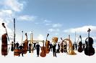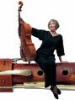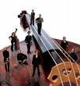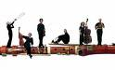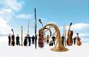

presents
a new production
of

Georg Friedrich Händel’s
Baroque Masterpiece
Tamerlano
opera in three acts
sung in English from a specially commissioned new translation

featuring players from:
The Orchestra of the Age of Enlightenment
The English Baroque Soloists
The Academy of Ancient Music

and singers who regularly appear with
Glyndebourne, English National Opera & Scottish Opera

November 1st to November 5th 2007
E M Forster Theatre, Tonbridge School, Kent

Sponsorship & Corporate Hospitality Opportunities

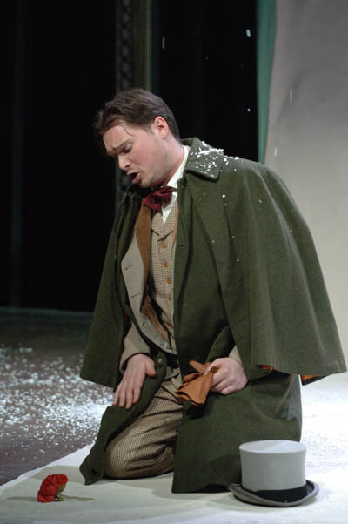
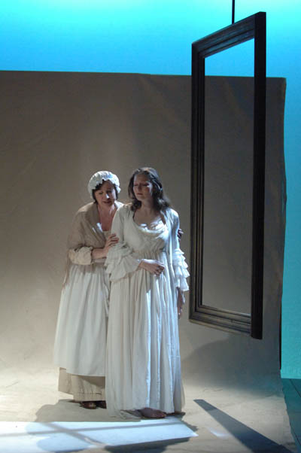
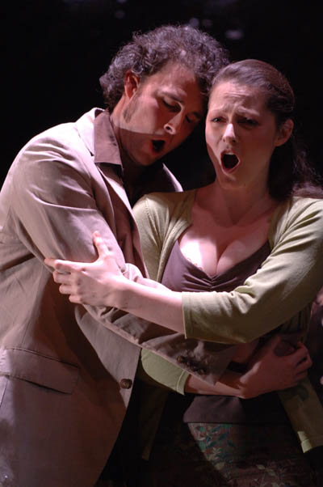

opera by definition is offering the following sponsorship opportunities for its next production of Händel’s baroque opera masterpiece Tamerlano:

• The Baroque Orchestra: total sponsorship required: £25,000
5 tranches of £5,000 available

• Education: total sponsorship required: £12,000
3 tranches available for:
In-school workshops: £3,000 Schools performance: £3,000 Understudies: £6,000

• Costumes: total sponsorship required: £3,000

• Principal Artists: total sponsorship required: £18,000
6 tranches available, of £3,000 per principal artist

• Production Fund for Scenery, Lighting & Props:
total sponsorship required: £20,000
4 tranches of £5,000 available
You may also sponsor this production by buying opera by definition’s Baroque Hospitality Package at £120 per ticket. Benefits are:
• VIP check - in
• Best seat or seats for a performance of your choice
• Complimentary programme
• Pre-show and first interval drinks & canapés. Second interval coffee and mints
• Access to a private room at the venue for your own private reception with hospitality manager
• Tickets and opera synopsis sent in advance by way of ‘invitation’
• Line entry of your name/company in theatre programme

Additionally we are offering the opportunity of underwriting Box Office sales. Our total expected Box Office, at 90% of seating capacity (the average we have achieved over previous productions), is £34,000. We are seeking 4 sponsors to underwrite 25% of any shortfall against this. Thus, if our Box Office is £30,000, each 25% sponsor will contribute £1,000 to the shortfall.

Sponsorship Benefits

As a sponsor of opera by definition’s new production of Händel’s Tamerlano, your benefits include:

- Accreditation as sponsor with your company logo in the programme, on our web site and in all marketing materials including press releases and posters

- Association with a professional, ambitious and successful opera company

- Allocation of tickets and signed programmes for the best seats in the house on the evening of your choice

- High level networking opportunities at the Opening Night Reception

- Access to a private room at the venue for your own private reception with hospitality manager

- Priority booking and incentives to your staff

- A pre performance talk to unwrap the opera

- Opportunity to demonstrate your commitment to that most powerful of all encompassing art-forms – the opera

- Opportunity to meet the cast, director of music and stage director

Contact
If you would like take advantage of any of these sponsorship opportunities, or would like further information, please contact Bruce J Williams (Development Director) on +44 (0) 1892 785778 or Email: brucewilliams@operabydefinition.co.uk

For further information please visit our web site at:
www.operabydefinition.co.uk

Pictures displayed are from the 2006 production of Tchaikovsky’s opera Eugene Onegin. © Mike Hoban

