HELP OUR WOUNDED SERVICEMEN AND WOMEN
Can you support Phil Packer to raising £1 million in support of Help for Heroes?
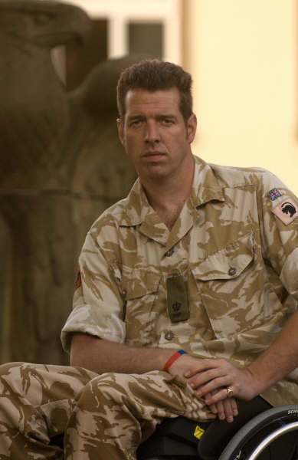
Major Phil Packer, was injured in an incident following a rocket attack in Basra on 19 Feb 08. Sadly, as a result of the accident he lost the use of his legs and is now a paraplegic with what are classed as catastrophic injuries. He was originally told he would never walk again, however there have been positive improvements and it is his intent to walk the London Marathon on the 26th April this year over a two week period on crutches.
He continues to serve in the Army and until he returns to work, is determined to assist others and provide information on sport to the disabled community; he believes it is his responsibility to do so. He has also pledged to raise £1 million for Help for Heroes as Phil hopes to make a difference to fellow injured servicemen and women.
Phil needs support to make his Quest a success. He is supported by family, friends, colleagues and those that hear about his story. To enthuse and inspire others, Phil has laid down the gauntlet for ANY challenges, events or sports to participate in, that will assist him in reaching his target. Amazingly, within a year of his injuries, he rowed the English Channel with Al Humphreys in just over fifteen hours.
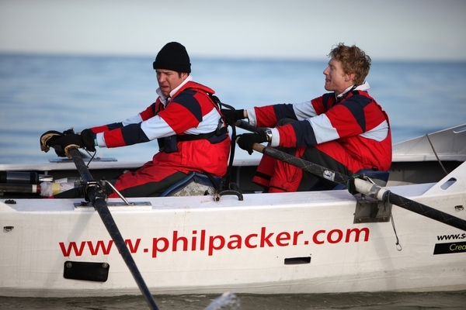
Phil rowing the English Channel with Al Humphreys on the 14th February 2009
How can you help?
Phil has a website called www.philpacker.com; it is becoming something of a focal point for inspiration and support for others; it is a selfless quest. If you can give a Donation through his secure website and spread the word, then you will join others that are showing their support for this remarkable man. Your support will show that people do believe in what he is trying to achieve.
If you want to donate to Phil’s £1Million Quest, his secure Link is on the website (www.justgiving.com/philsmillion) or details for sending a cheque can be found on his Contact Page. This is really all about him gaining support Nationally and us spreading the word; if you can help in any way, it will be sincerely appreciated and will assist in his unique journey to benefit others.
We’re supporting Phil. Are you?

