Premier Pre Dressage
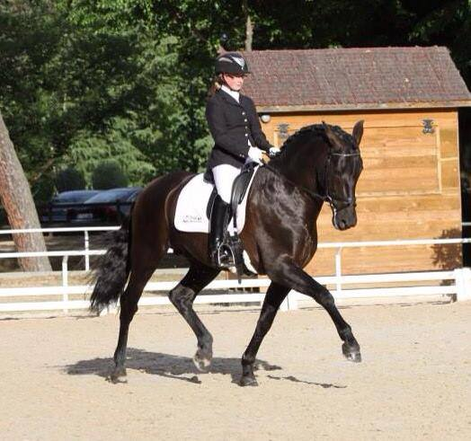
Alice Hurley and Deseado CCV winning at the VIII Festival of Dressage, Madrid, 25th May 2014
International rider 26 year old Alice Hurley has competed in affiliated dressage for the last 15 years after winning the National Talent Spotting in 1999. She has represented Great Britain on several occasions in Spain, England, Holland, Ireland and Northern Ireland. Currently trained by Olympian, Richard Davison, and Spanish Grand Prix Rider, Victor Alvarez, she is a determined, dedicated and an ambitious rider able to compete all types of horses. She works for Premier PRE Dressage competing her owner, Karen Bourdon’s, Spanish dressage horses currently in England and Spain. She has a friendly, patient, calm and sympathetic approach to her training in order to inspire confidence and perfection in each horse.
Results speak for themselves, Alice has produced and competed 7 year old black Andalusian (PRE) stallion “Deseado CCV”. See attached link on British Dressage news page http://www.britishdressage.co.uk/news/show/2054-hurley-and-deseado-make-their-mark-in-madrid for his most recent win 25th May 2014.
This talented partnership, which was placed second in the Petplan Equine Medium Open Area Festival Championship at Hartpury in April, will compete in advanced medium classes this year, working towards making their PSG debut in 2015.
Following on from the pair’s success at the Barcelona Spring Tour in March 2014, Alice and Deseado (pictured), won the Copa de ANCCE medal once again. This achievement secured their place at the PRE Dressage World Championships (SICAB) taking place in Seville on 2 – 7 December 2014, making them the first GB competitors ever to qualify for this pinnacle of the PRE calendar.
We have various sponsorship opportunities available. For further information, please contact Karen on 01869 340770 or via email on dressage@premierpre.com.

