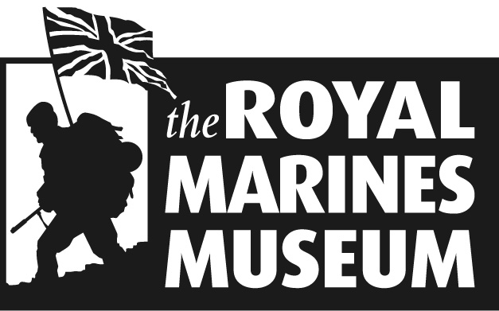

The Royal Marines Museum

Founded in 1958, the Museum is located in the former Officers’ Mess of Eastney Barracks in Portsmouth. Its prime location on the seafront provides a stunning backdrop for everyone who visits the Museum.

We believe that Portsmouth’s maritime heritage should be celebrated through preserving and presenting Royal Marines history in an innovative and enjoyable way.

How important are people to your business?

The Royal Marines offers a flexible sponsorship package. We know that the needs of a business can change rapidly, so we tailor our approach to suit you. A sponsorship with us presents the following opportunities for your business:

- Brand Development - A partnership with The Royal Marines Museum is integral to strengthening brand awareness and loyalty with clients both existing and potential.

- Public Relations - The Royal Marines Museum environment will present significant opportunities to raise your profile.

- Invest In People - To improve your staff incentive package, the Museum can provide many rewards and special offers.

- Entertainment and events - Corporate entertainment opportunities can be one of the most attractive benefits that a sponsorship can provide.

What would you like to sponsor?

There are always lots of exciting projects that require sponsorship within the Museum. However, if you have any ideas on the types of projects that you would like to sponsor we would only be too happy to discuss these with you.

What can we offer you?

The Museum offers bespoke sponsorship packages that are tailored specifically to meet the needs of your business. We suggest a meeting is arranged to discuss your individual requirements as the cost of sponsorship varies. This gives us the flexibility to offer you what is suitable for your budget.

Please call Michelle Rickman on 02392 819385 ext 242 to discuss further.

Or - michelle.rickman@royalmarinesmuseum.co.uk

